

**BasketBall Playground**

**Software Requirements Specification**

**SE150182 Nguyễn Minh Trung**

**SE150159 Võ Thị Tường Duy**

**SE150208 Trương Quan Tân**

**SE150249 Phạm Hà Giang**

**SE160197 Nguyễn Phước Tùng**

## **1. Introduction**

### **1.1. Purpose**

Basketball players may look for and reserve courts using Basketball Playground, a software platform. Basketball players may select whatever court time they want throughout the day thanks to this method. Additionally, yard owners have the right to register their yards in the system by speaking and coordinating with the system administrator.

### **1.2. Project Vision**

Customers who want to reserve a court to play basketball may get suggestions from courts that have received positive reviews from a large number of players and take the initiative to choose their playing time frame in accordance with the available slots in the system. system. An online application called Basketball Playground helps customers do activities including scheduling a basketball court reservation, seeing the court's details, viewing its history of reservations, and rating each service's performance.

Regarding yard administration, the program allows for the display, modification, and deletion of yard information as well as client information for booking the yard. Additionally, the owner has access to information on the level's growth and decline. making reservations, removing a customer's yard, and applying vouchers

The system also allows for linking yards in different regions together, making it simple for yard owners to join their yards together while also becoming well-known to many people thanks to the system. We are expanding the options available to clients for where to play basketball in order to improve the user experience.

## **2. Diagram**

### **2.2. Usecase**

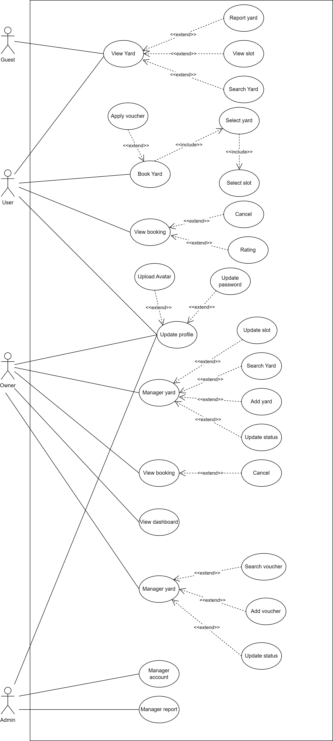

### **2.2. Activity diagram**

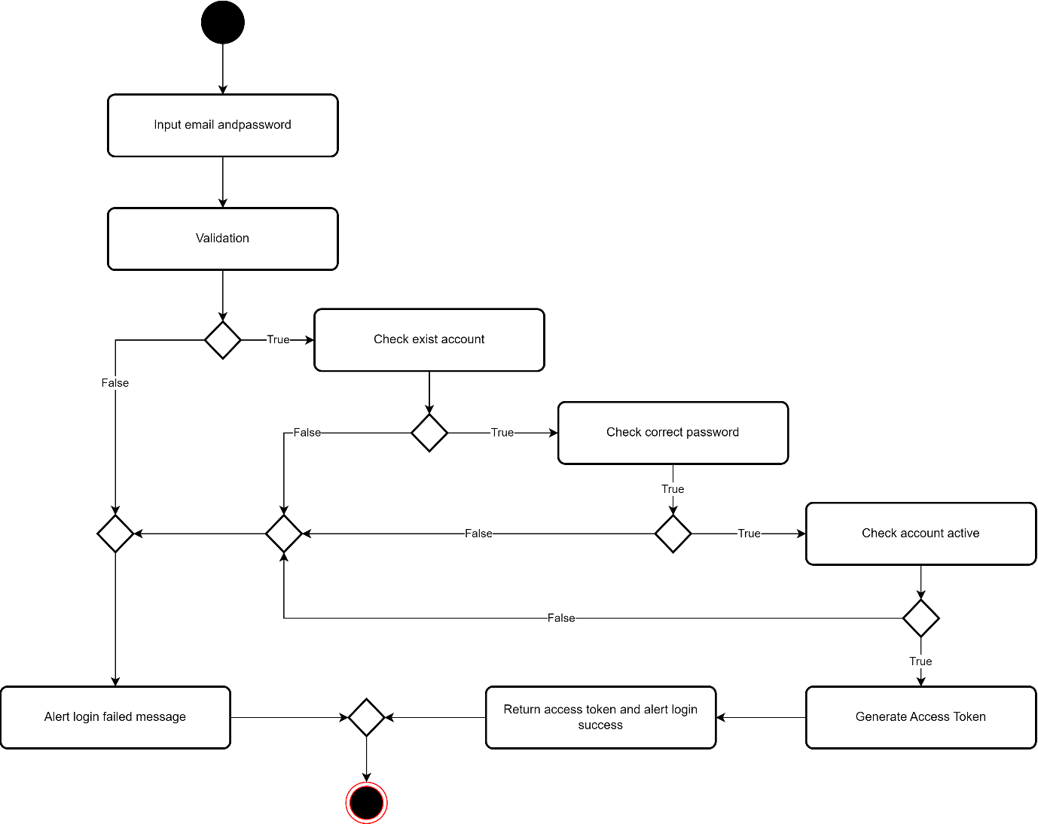

*2.2.1 Login*

*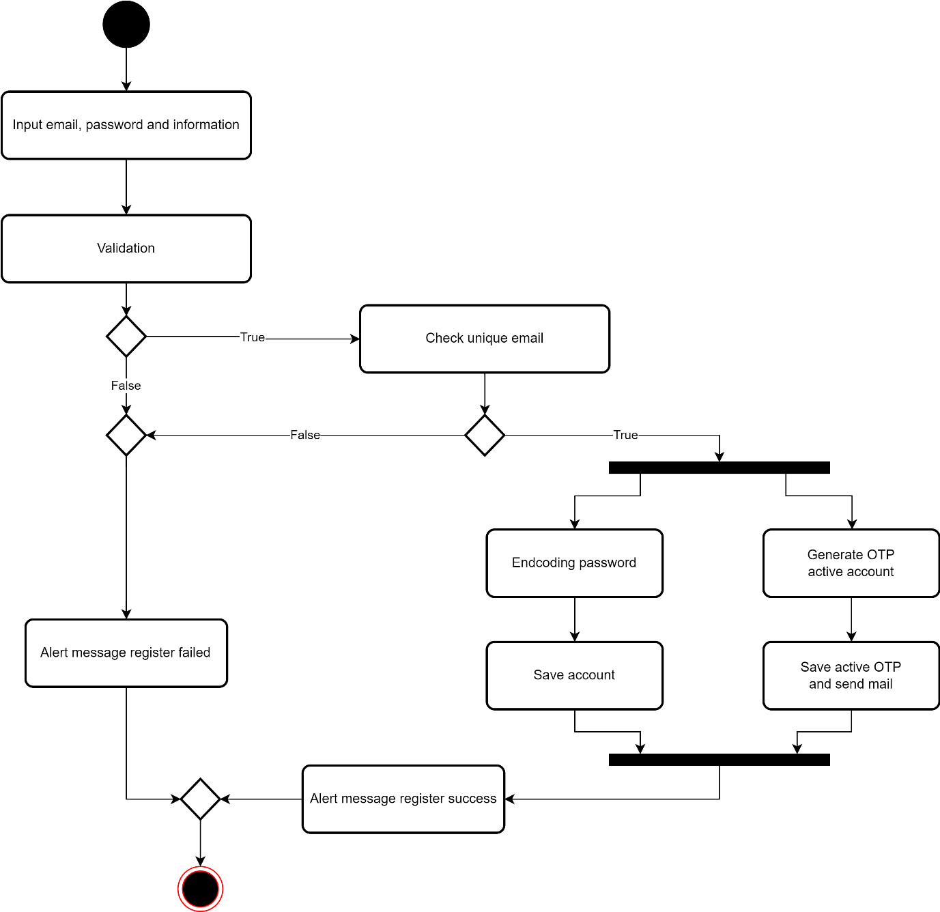2.2.2 Register*

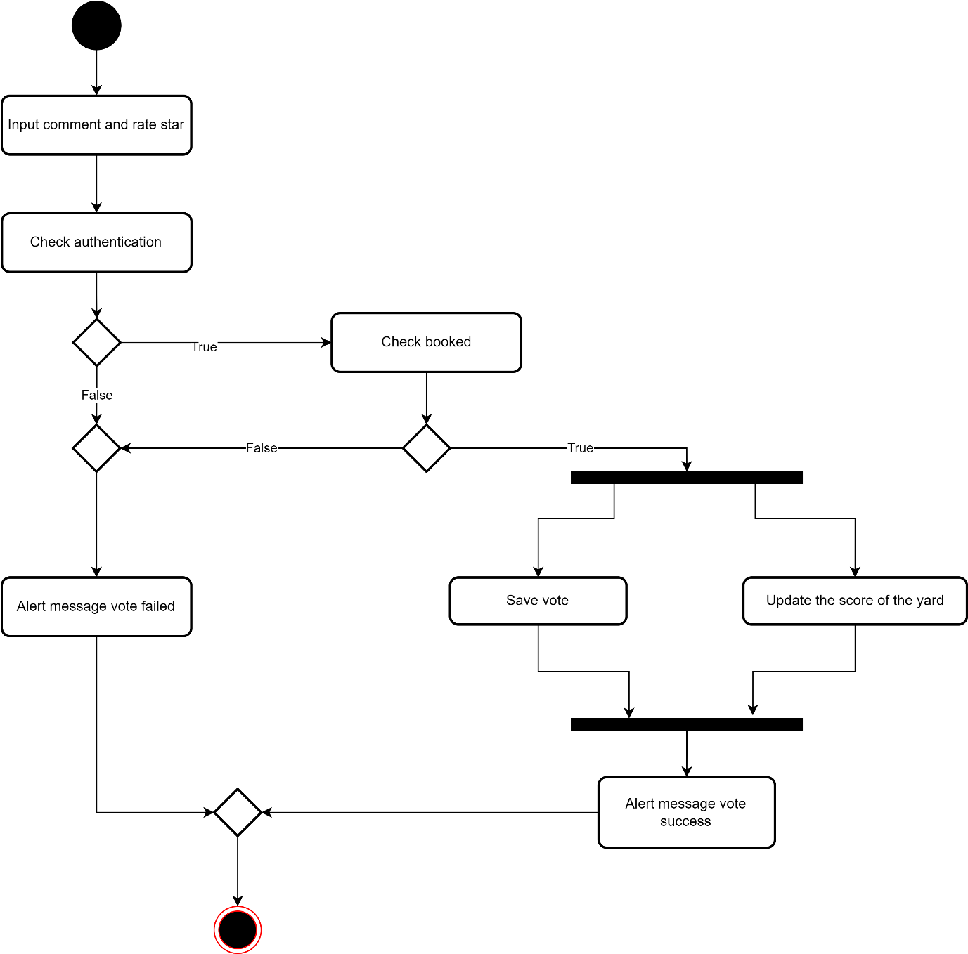

*2.2.3 User vote yard*

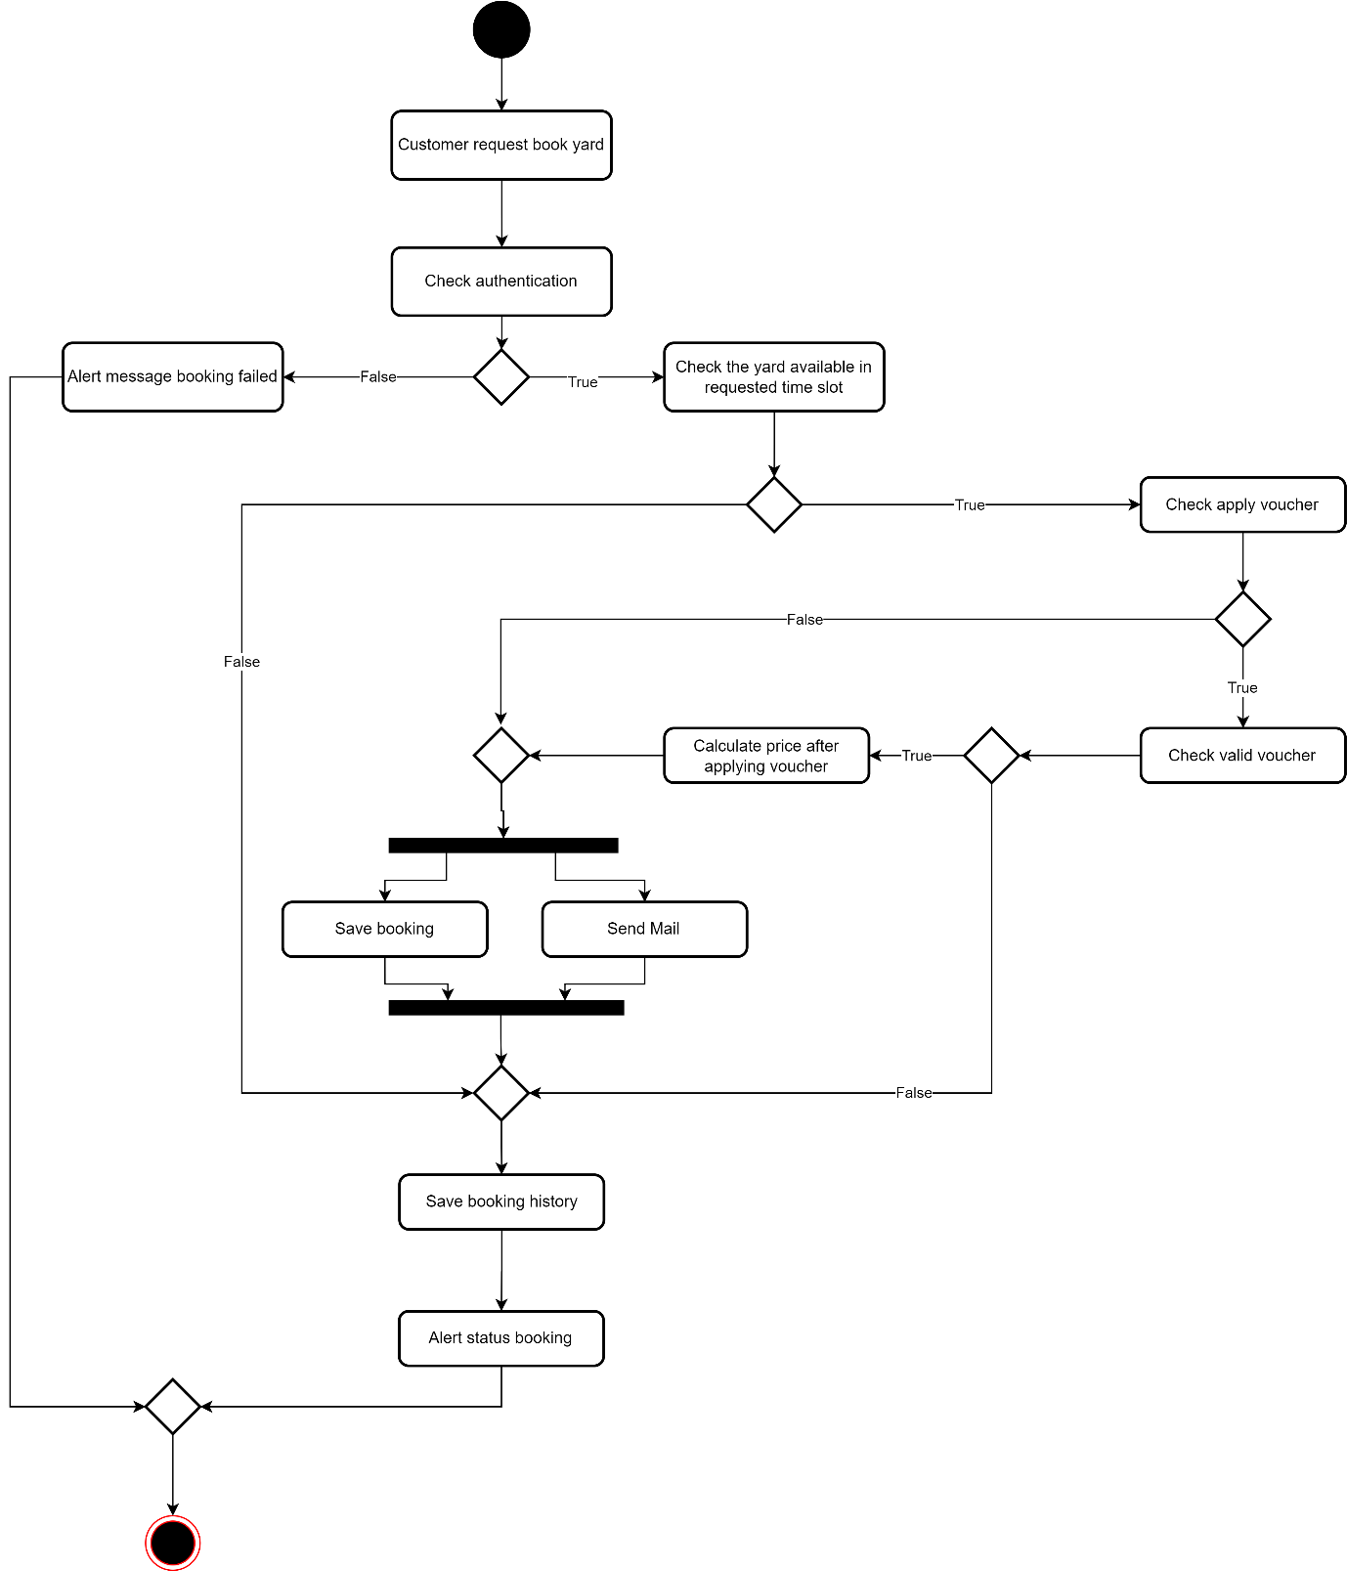

*2.2.4 User booking yard*

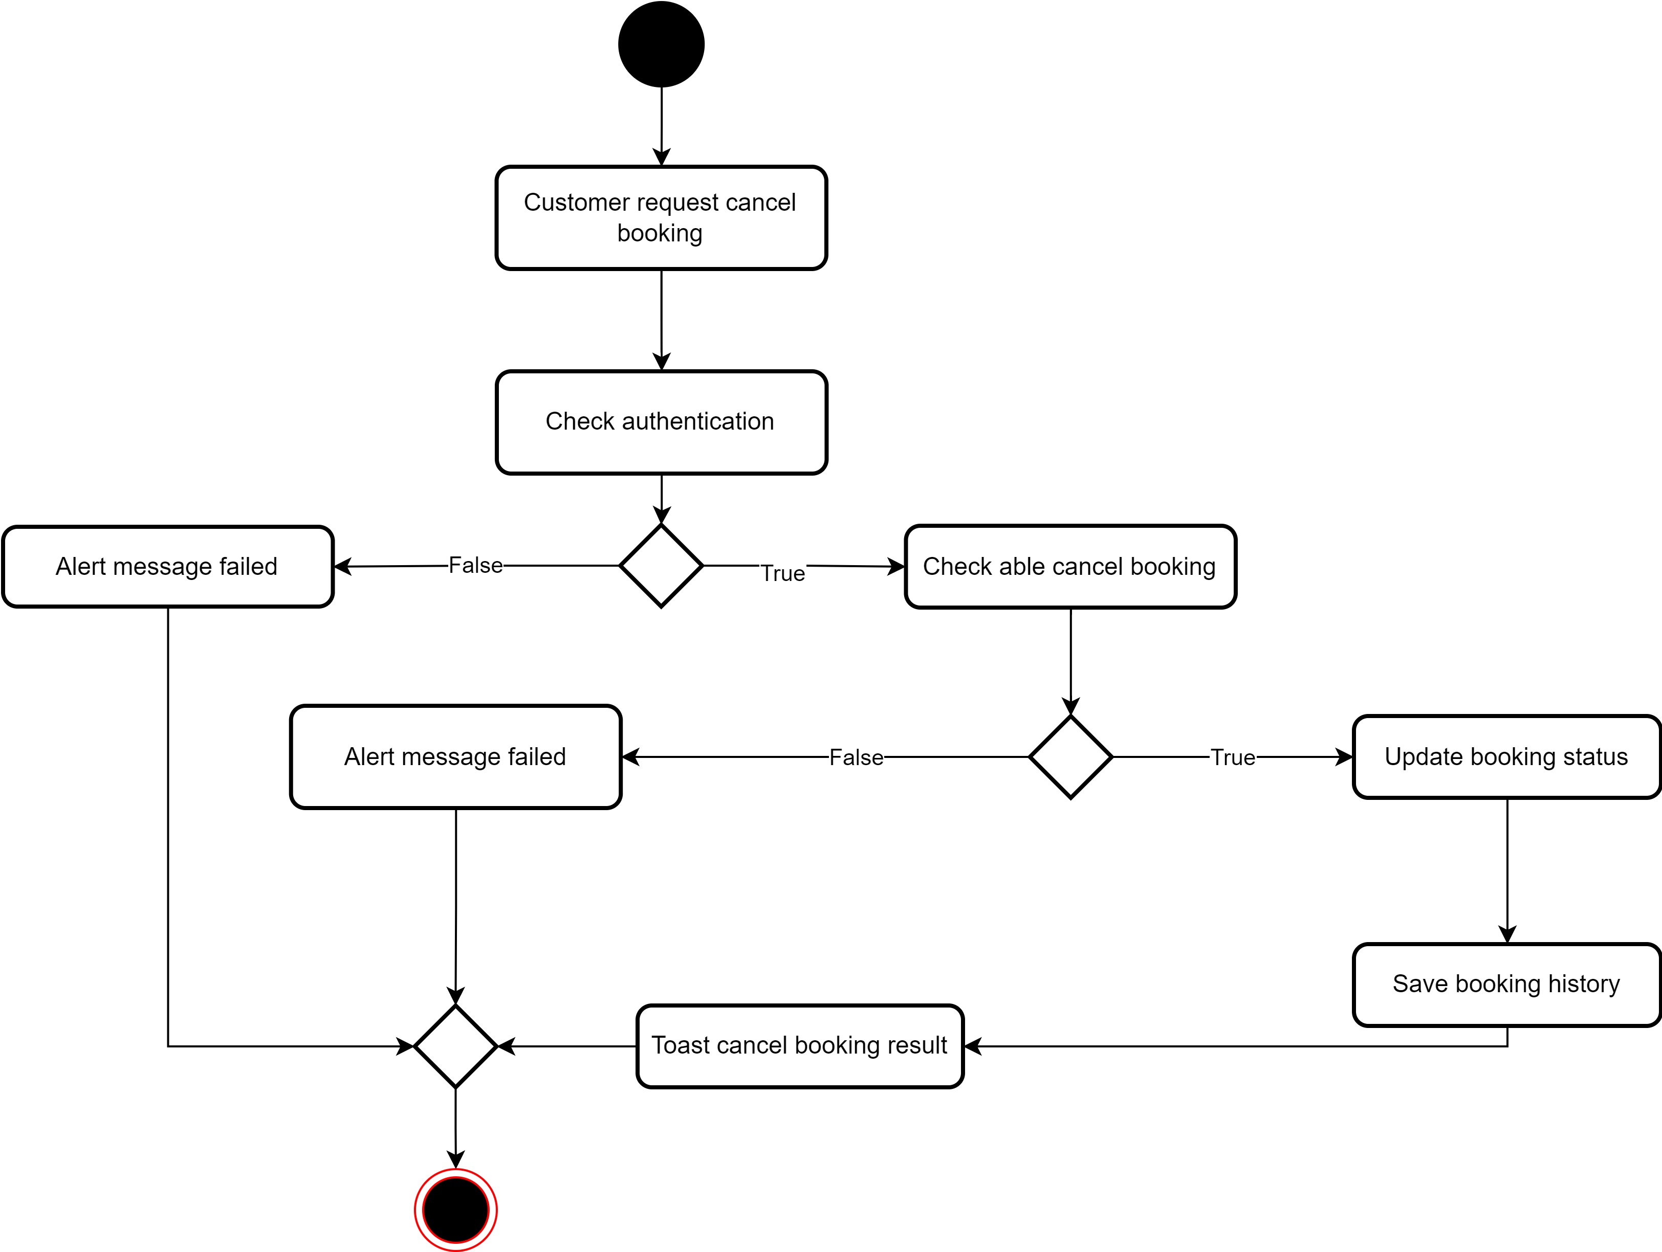

*2.2.5 User cancel booking*

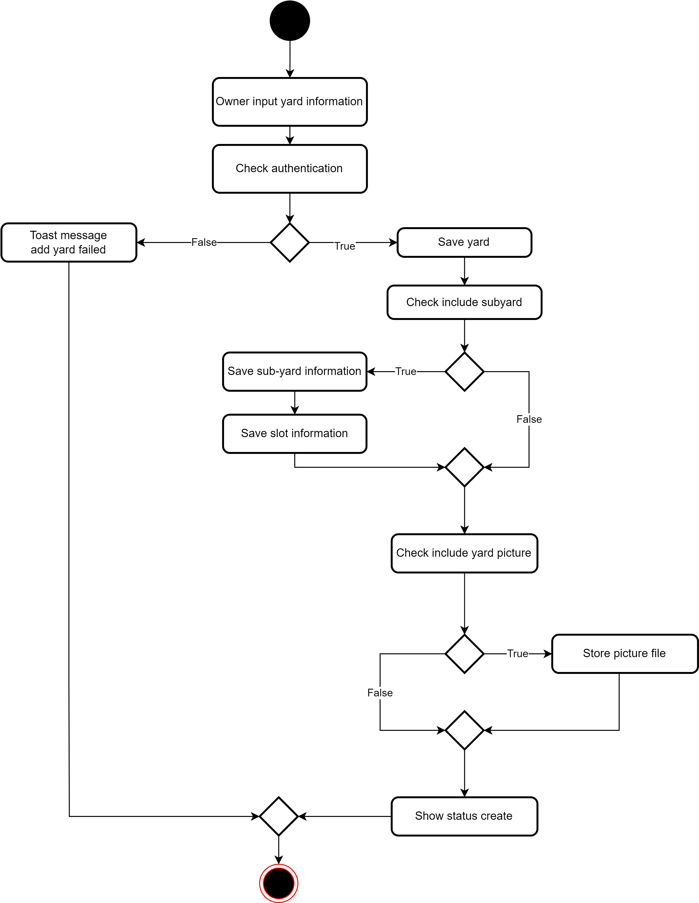

*2.2.6 Owner add yard*

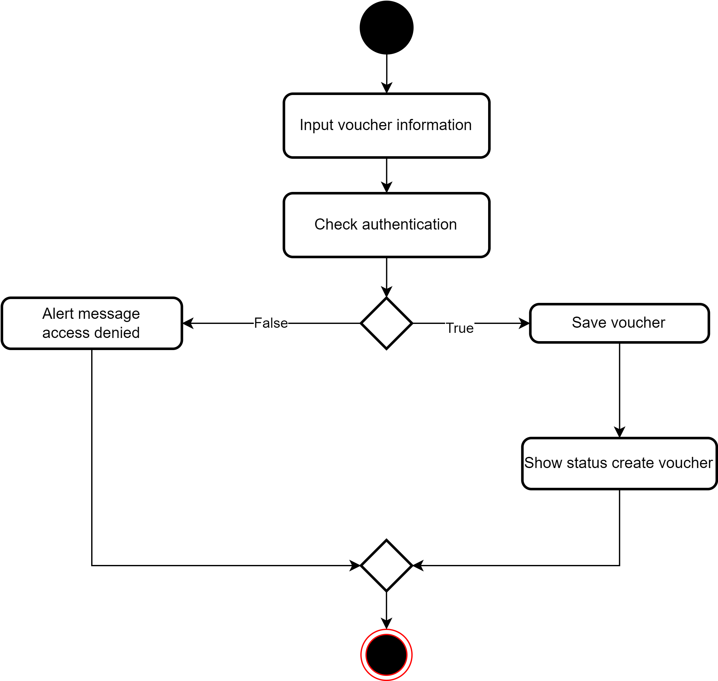

*2.2.7 Owner add voucher*

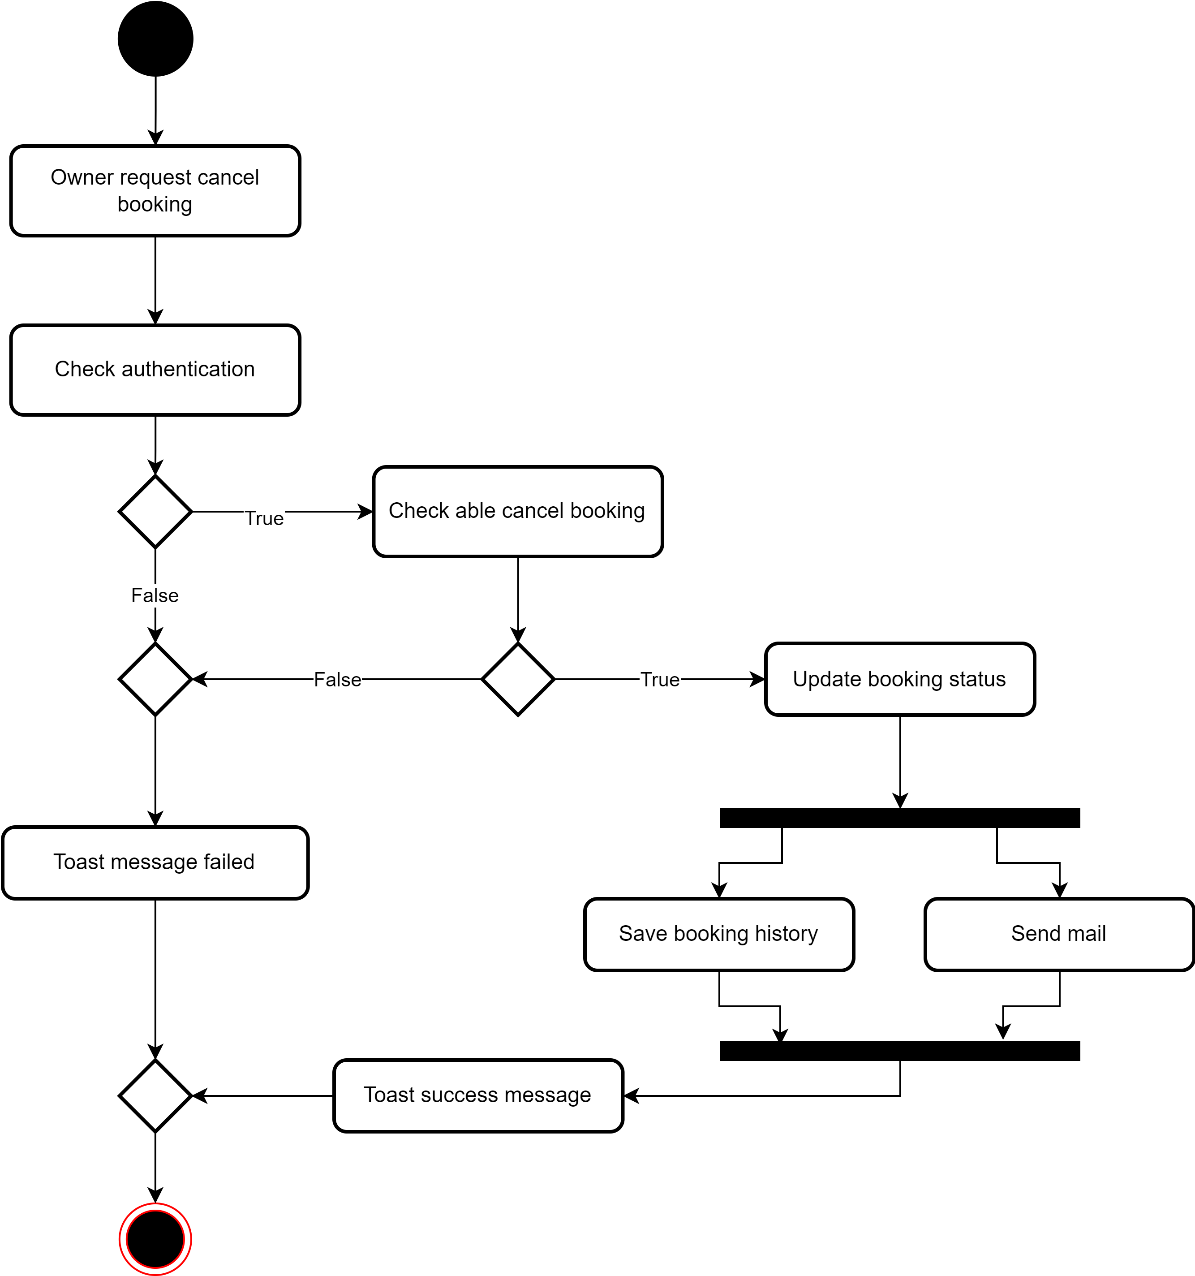

*2.2.8 Owner cancel booking*

## 

### **2.3. Class diagram**



**1. Account_Login**

Store the login information of login account.

|  |  |  |  |  |  |  |  |
| --- | --- | --- | --- | --- | --- | --- | --- |
| **#** | **Field name** | **Type** | **Size** | **Unique** | **Not Null** | **PK/FK** | **Notes** |
| 1 | id | Int | 4 | x | x | PK | Identity Column |
| 2 | account_id | varchar(50) | 50 |  | x | FK | References account(id) |
| 3 | access_token | text |  |  |  |  | JWT token of the login of user |
| 4 | is_logout | boolean | 2 |  |  |  |  |

**2. Account_Otp**

Store the OTP information of accounts. Use when registering or forgot password.

|  |  |  |  |  |  |  |  |
| --- | --- | --- | --- | --- | --- | --- | --- |
| **#** | **Field name** | **Type** | **Size** | **Unique** | **Not Null** | **PK/FK** | **Notes** |
| 1 | id | Int | 4 | x | x | PK | Identity Column |
| 2 | account_id | varchar(50) | 50 |  | x | FK | References account(id) |
| 3 | otp_code | varchar(6) | 6 |  |  |  | OTP code for this account |
| 4 | expire_at | timestamp | 32 |  |  |  | The time the OTP expire |
| 5 | create_at | timestamp | 32 |  |  |  | The time the OTP was created |

**3. Accounts**

Store the information of accounts.

|  |  |  |  |  |  |  |  |
| --- | --- | --- | --- | --- | --- | --- | --- |
| **#** | **Field name** | **Type** | **Size** | **Unique** | **Not Null** | **PK/FK** | **Notes** |
| 1 | id | varchar(50) | 50 | x | x | PK |  |
| 2 | role_id | int | 4 |  | x | FK | References roles(id) |
| 3 | email | varchar(50) | 50 | x | x |  |  |
| 4 | phone | varchar(10) | 10 | x | x |  |  |
| 5 | full_name | varchar(100) | 100 |  | x |  |  |
| 6 | password | varchar(200) | 200 |  | x |  |  |
| 7 | avatar_url | varchar(200) | 200 |  |  |  | The url of avatar storage in firebase. |
| 8 | is_confirmed | boolean | 2 |  |  |  |  |
| 9 | is_active | boolean | 2 |  |  |  | The information that whether the account is active or be disabled by admin |
| 10 | create_at | timestamp | 32 |  |  |  |  |

**4. Roles**

Store the role information of account in application.

|  |  |  |  |  |  |  |  |
| --- | --- | --- | --- | --- | --- | --- | --- |
| **#** | **Field name** | **Type** | **Size** | **Unique** | **Not Null** | **PK/FK** | **Notes** |
| 1 | id | Int | 4 | x | x | PK | Identity Column |
| 2 | role_name | varchar(50) | 50 |  | x |  |  |

**5. Districts**

Store the districts information in application.

|  |  |  |  |  |  |  |  |  |
| --- | --- | --- | --- | --- | --- | --- | --- | --- |
| **#** | **Field name** | **Type** | **Size** | **Unique** | **Not Null** | | **PK/FK** | **Notes** |
| 1 | id | Int | 4 | x | x | PK | | Identity Column |
| 2 | province_id | Int | 4 |  | x | FK | | References provinces(id) |
| 3 | district_name | varchar(50) | 50 |  |  |  | |  |

**6. Yards**

Store the yards information in application.

|  |  |  |  |  |  |  |  |
| --- | --- | --- | --- | --- | --- | --- | --- |
| **#** | **Field name** | **Type** | **Size** | **Unique** | **Not Null** | **PK/FK** | **Notes** |
| 1 | id | varchar(50) | 50 | x | x | PK |  |
| 2 | name | varchar(45) | 45 |  |  |  |  |
| 3 | create_at | timestamp | 32 |  |  |  |  |
| 4 | address | varchar(100) | 100 |  |  |  |  |
| 5 | district_id | int | 4 |  | x | FK | References districts(id) |
| 6 | is_active | Boolean | 2 |  |  |  |  |
| 7 | is_deleted | Boolean | 2 |  |  |  |  |
| 8 | owner_id | varchar(50) | 50 |  | x | FK | References accounts(id)  The id of the owner of this yard |
| 9 | open_at | time |  |  |  |  |  |
| 10 | close_at | time |  |  |  |  |  |
| 11 | slot_duration | int | 4 |  |  |  | Store the minute of a slot |
| 12 | score | int | 4 |  |  |  | Store the average score after rating. |
| 13 | number_of_vote | int | 4 |  |  |  |  |
| 14 | reference | int | 4 |  |  |  | Identity Column |
| 15 | created_at | timestamp | 32 |  |  |  |  |
| 16 | number_of_bookings | int | 4 |  |  |  |  |

**7. Sub_Yards**

Store the sub-yards information in a yard.

|  |  |  |  |  |  |  |  |
| --- | --- | --- | --- | --- | --- | --- | --- |
| **#** | **Field name** | **Type** | **Size** | **Unique** | **Not Null** | **PK/FK** | **Notes** |
| 1 | id | varchar(50) | 50 | x | x | PK |  |
| 2 | name | varchar(100) | 100 |  |  |  |  |
| 3 | parent_yard | varchar(50) | 50 |  | x | FK | references yards(id) |
| 4 | type_yard | int | 4 |  | x | FK | references type_yards(id) |
| 5 | created_at | timestamp | 32 |  |  |  |  |
| 6 | is_active | Boolean | 2 |  |  |  |  |
| 7 | is_deleted | Boolean | 2 |  |  |  |  |
| 8 | is_parent_active | Boolean | 2 |  |  |  |  |
| 9 | reference | int | 4 |  |  |  | Identity Column |
| 10 | updated_at | timestamp | 32 |  |  |  |  |

**8. Slots**

Store the slots information in a sub_yard.

|  |  |  |  |  |  |  |  |
| --- | --- | --- | --- | --- | --- | --- | --- |
| **#** | **Field name** | **Type** | **Size** | **Unique** | **Not Null** | **PK/FK** | **Notes** |
| 1 | id | int | 4 | x | x | PK |  |
| 2 | price | int | 4 |  |  |  |  |
| 3 | ref_yard | varchar(50) | 50 |  | x | FK | references yards(id) |
| 4 | start_time | timestamp | 32 |  |  |  |  |
| 5 | end_time | timestamp | 32 |  |  |  |  |
| 6 | is_active | Boolean | 2 |  |  |  |  |
| 7 | is_parent_active | Boolean | 2 |  |  |  |  |

**9. Type_Yards**

Store the type information of yard in application.

|  |  |  |  |  |  |  |  |
| --- | --- | --- | --- | --- | --- | --- | --- |
| **#** | **Field name** | **Type** | **Size** | **Unique** | **Not Null** | **PK/FK** | **Notes** |
| 1 | id | Int | 4 | x | x | PK | Identity Column |
| 2 | type_name | varchar(10) | 10 |  | x |  |  |

**10. Bookings**

Store the bookings information.

|  |  |  |  |  |  |  |  |
| --- | --- | --- | --- | --- | --- | --- | --- |
| **#** | **Field name** | **Type** | **Size** | **Unique** | **Not Null** | **PK/FK** | **Notes** |
| 1 | id | varchar(50) | 50 | x | x | PK |  |
| 2 | slot_id | int | 4 |  |  | FK | references slots(id)  Specify the slot of this booking. |
| 3 | account_id | varchar(50) | 50 |  | x | FK | references accounts(id)  The user booked. |
| 4 | status | varchar(20) | 20 |  |  |  |  |
| 5 | date | timestamp | 32 |  |  |  |  |
| 6 | note | varchar(200) | 200 |  |  |  |  |
| 7 | price | int | 4 |  |  |  |  |
| 8 | book_at | timestamp | 32 |  |  |  |  |
| 9 | reference | int | 4 |  |  |  | Identity Column |
| 10 | sub_yard_id | varchar(50) | 50 |  | x |  | Specify the subyard of this booking.  Added for optimize query. |
| 11 | big_yard_id | varchar(50) | 50 |  | x |  | Specify the yard of this booking.  Added for optimize query. |
| 12 | original_price | int | 4 |  |  |  |  |
| 13 | voucher_code | varchar(20) | 20 |  |  |  |  |

**11. Booking_History**

Store the history of bookings information.

|  |  |  |  |  |  |  |  |
| --- | --- | --- | --- | --- | --- | --- | --- |
| **#** | **Field name** | **Type** | **Size** | **Unique** | **Not Null** | **PK/FK** | **Notes** |
| 1 | id | varchar(50) | 50 | x | x | PK |  |
| 2 | booking_id | varchar(50) | 50 |  | x | FK | references booking(id) |
| 3 | created_by | varchar(50) | 50 |  | x | FK | references accounts(id)  The user modify this booking. |
| 4 | booking_status | varchar(20) | 20 |  |  |  | The status of booking in this time. |
| 5 | created_at | timestamp | 32 |  |  |  |  |
| 6 | note | varchar(200) | 200 |  |  |  |  |
| 7 | reference | int | 4 |  |  |  | Identity Column |

**12. Votes**

Store the votes information of users.

|  |  |  |  |  |  |  |  |
| --- | --- | --- | --- | --- | --- | --- | --- |
| **#** | **Field name** | **Type** | **Size** | **Unique** | **Not Null** | **PK/FK** | **Notes** |
| 1 | id | varchar(50) | 50 | x | x | PK |  |
| 2 | booking_id | varchar(50) | 50 |  | x | FK | references booking(id) |
| 3 | score | int | 4 |  |  |  |  |
| 4 | comment | varchar(200) | 200 |  |  |  |  |
| 5 | date | timestamp | 32 |  |  |  |  |
| 6 | is_deleted | Boolean | 2 |  |  |  |  |

**13. Vouchers**

Store the vouchers information of owners.

|  |  |  |  |  |  |  |  |
| --- | --- | --- | --- | --- | --- | --- | --- |
| **#** | **Field name** | **Type** | **Size** | **Unique** | **Not Null** | **PK/FK** | **Notes** |
| 1 | id | varchar(50) | 50 | x | x | PK |  |
| 2 | type | varchar(20) | 20 |  |  |  |  |
| 3 | title | varchar(200) | 200 |  |  |  |  |
| 4 | description | text |  |  |  |  |  |
| 5 | is_active | Boolean | 2 |  |  |  |  |
| 6 | max_quantity | int | 4 |  |  |  |  |
| 7 | usages | int | 4 |  |  |  |  |
| 8 | voucher_code | varchar(20) | 20 |  |  |  |  |
| 9 | percent_discount | int | 4 |  |  |  |  |
| 10 | amount_discount | int | 4 |  |  |  |  |
| 11 | start_date | timestamp | 32 |  |  |  |  |
| 12 | end_date | timestamp | 32 |  |  |  |  |
| 13 | status | varchar(20) | 20 |  |  |  |  |
| 14 | created_by | varchar(50) | 50 |  | x | FK | references accounts(id) |
| 15 | created_at | timestamp | 32 |  |  |  |  |
| 16 | reference | int | 4 |  |  |  | identity column |

**14. Yard_Picture**

Store the picture url of yards.

|  |  |  |  |  |  |  |  |
| --- | --- | --- | --- | --- | --- | --- | --- |
| **#** | **Field name** | **Type** | **Size** | **Unique** | **Not Null** | **PK/FK** | **Notes** |
| 1 | id | int | 4 | x | x | PK | identity column |
| 2 | ref_id | varchar(50) | 50 |  | x | FK | references yards(id) |
| 3 | image | varchar(200) | 200 |  | x |  |  |

**15. Yard_Report**

Store the report information of yards.

|  |  |  |  |  |  |  |  |
| --- | --- | --- | --- | --- | --- | --- | --- |
| **#** | **Field name** | **Type** | **Size** | **Unique** | **Not Null** | **PK/FK** | **Notes** |
| 1 | id | varchar(50) | 50 | x | x | PK |  |
| 2 | user_id | varchar(50) | 50 |  | x | FK | references accounts(id)  The user reported. |
| 3 | yard_id | varchar(50) | 50 |  | x | FK | references yards(id)  The yard to be reported. |
| 4 | reason | varchar(300) | 300 |  |  |  |  |
| 5 | created_at | timestamp | 32 |  |  |  |  |
| 6 | updated_at | timestamp | 32 |  |  |  |  |
| 7 | status | varchar(50) | 50 |  |  |  |  |
| 8 | reference | int | 4 |  |  |  | identity column |

**16. Provinces**

Store the role information of account in application.

|  |  |  |  |  |  |  |  |
| --- | --- | --- | --- | --- | --- | --- | --- |
| **#** | **Field name** | **Type** | **Size** | **Unique** | **Not Null** | **PK/FK** | **Notes** |
| 1 | id | Int | 4 | x | x | PK | Identity Column |
| 2 | province_name | varchar(50) | 50 |  | x |  |  |

### **2.4. Sequence diagram**

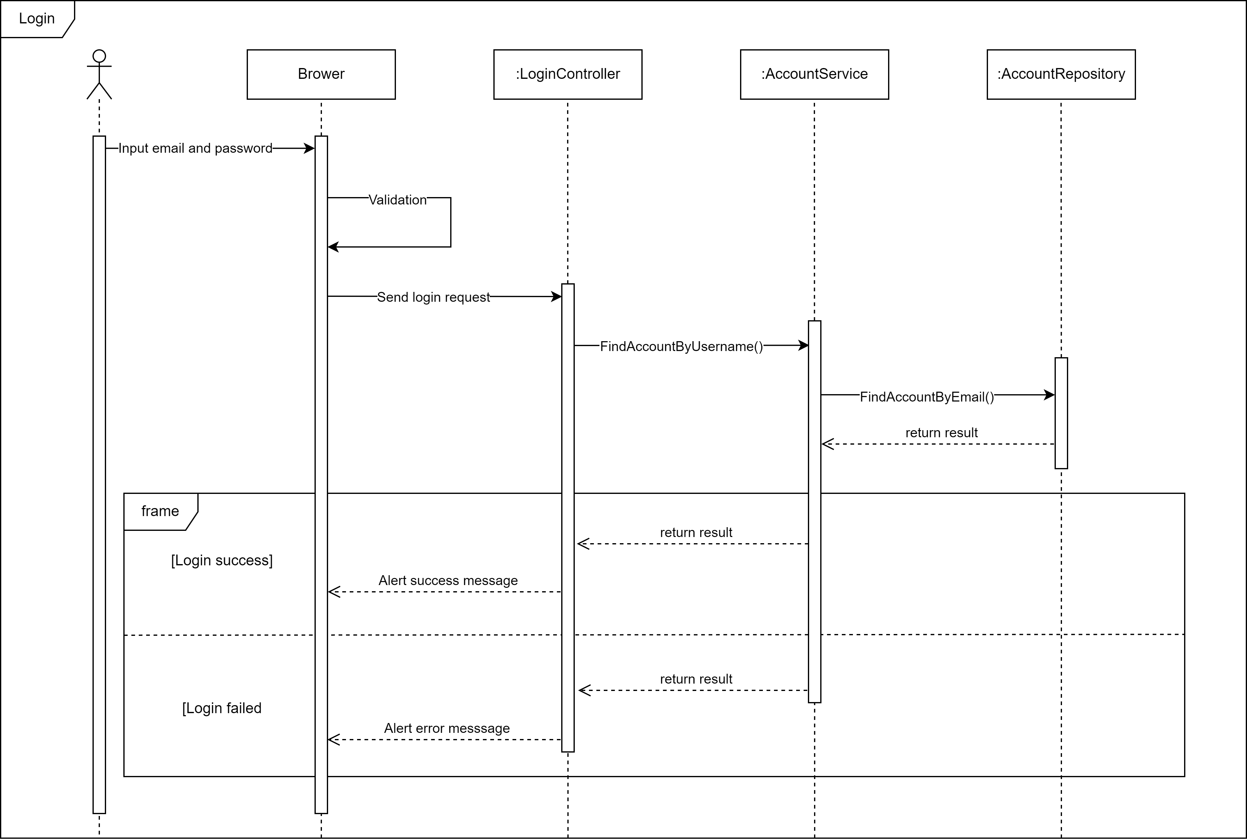

*2.4.1 Login*

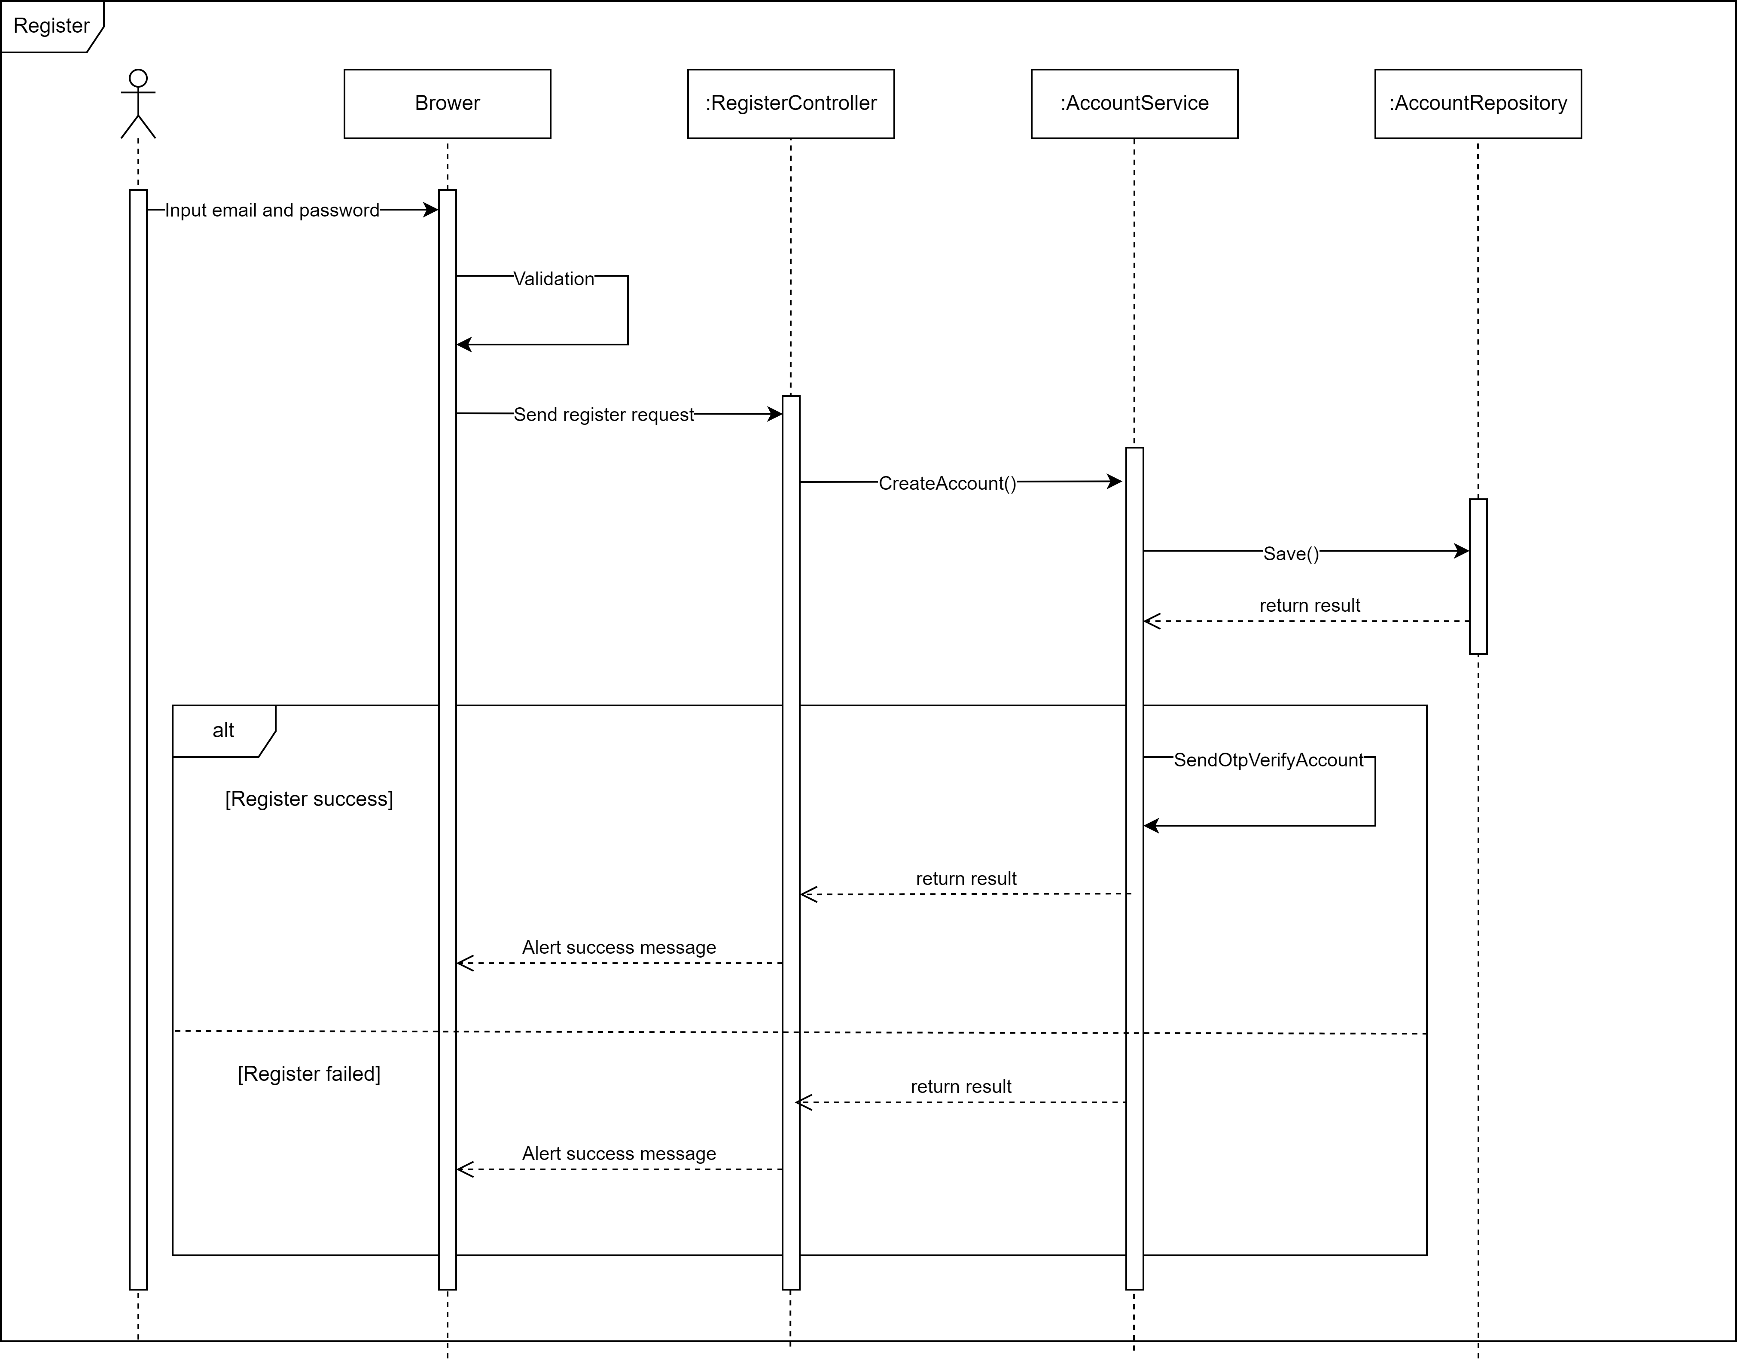

*2.4.2 Register*

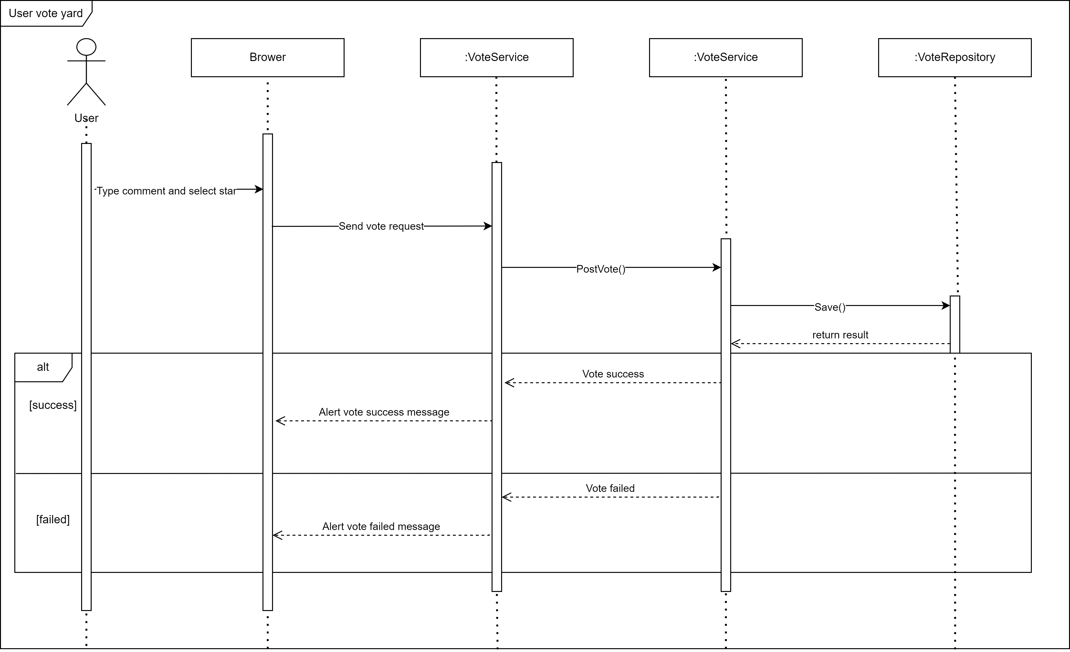

*2.4.3 User vote yard*

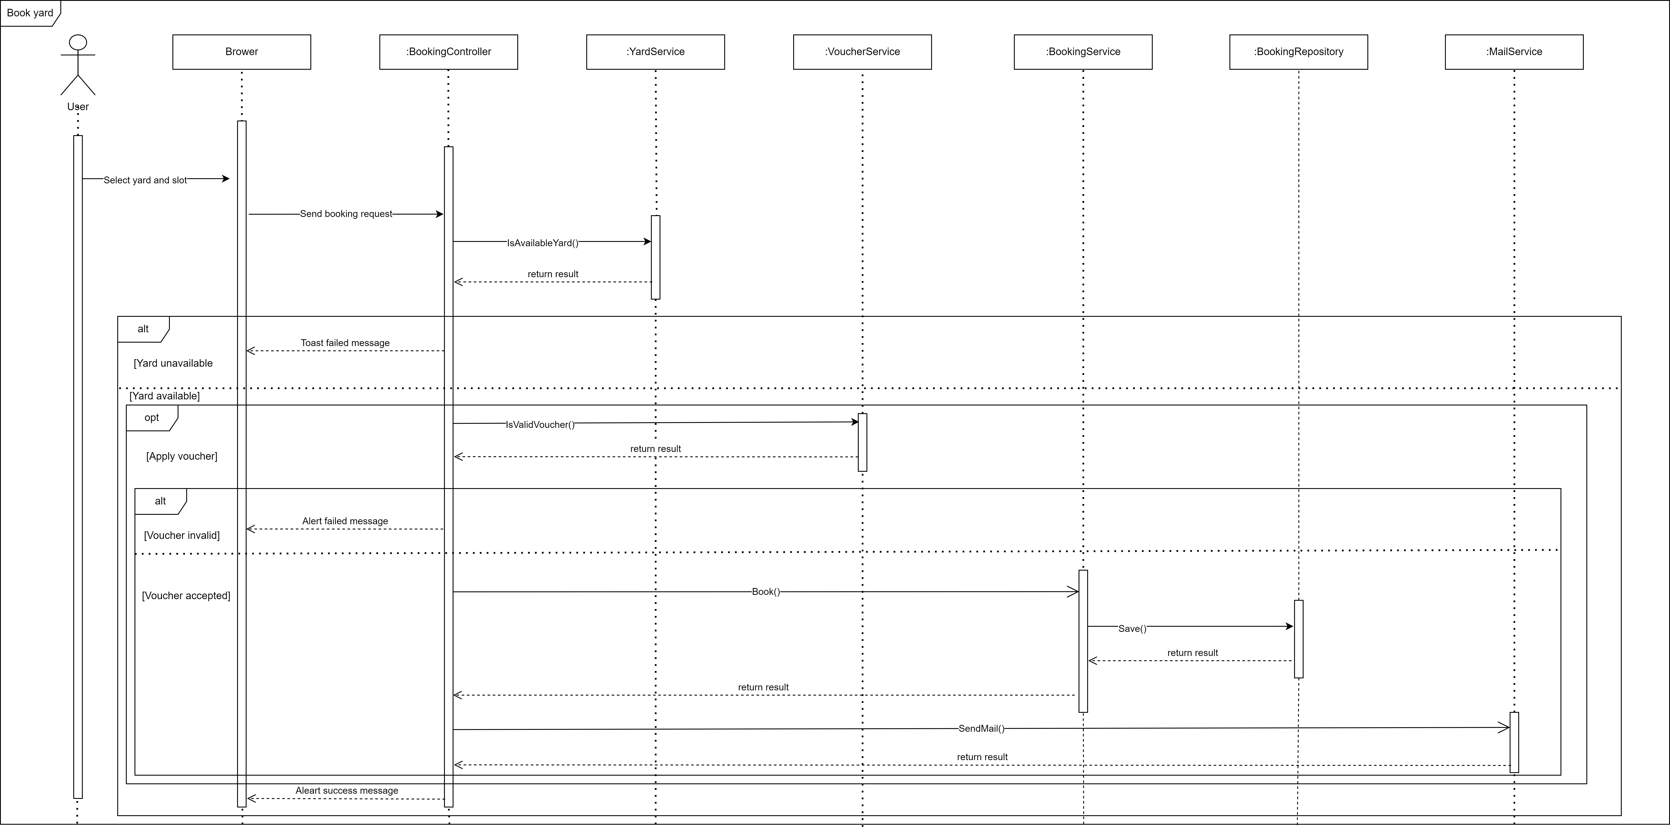

*2.4.4 User booking yard*

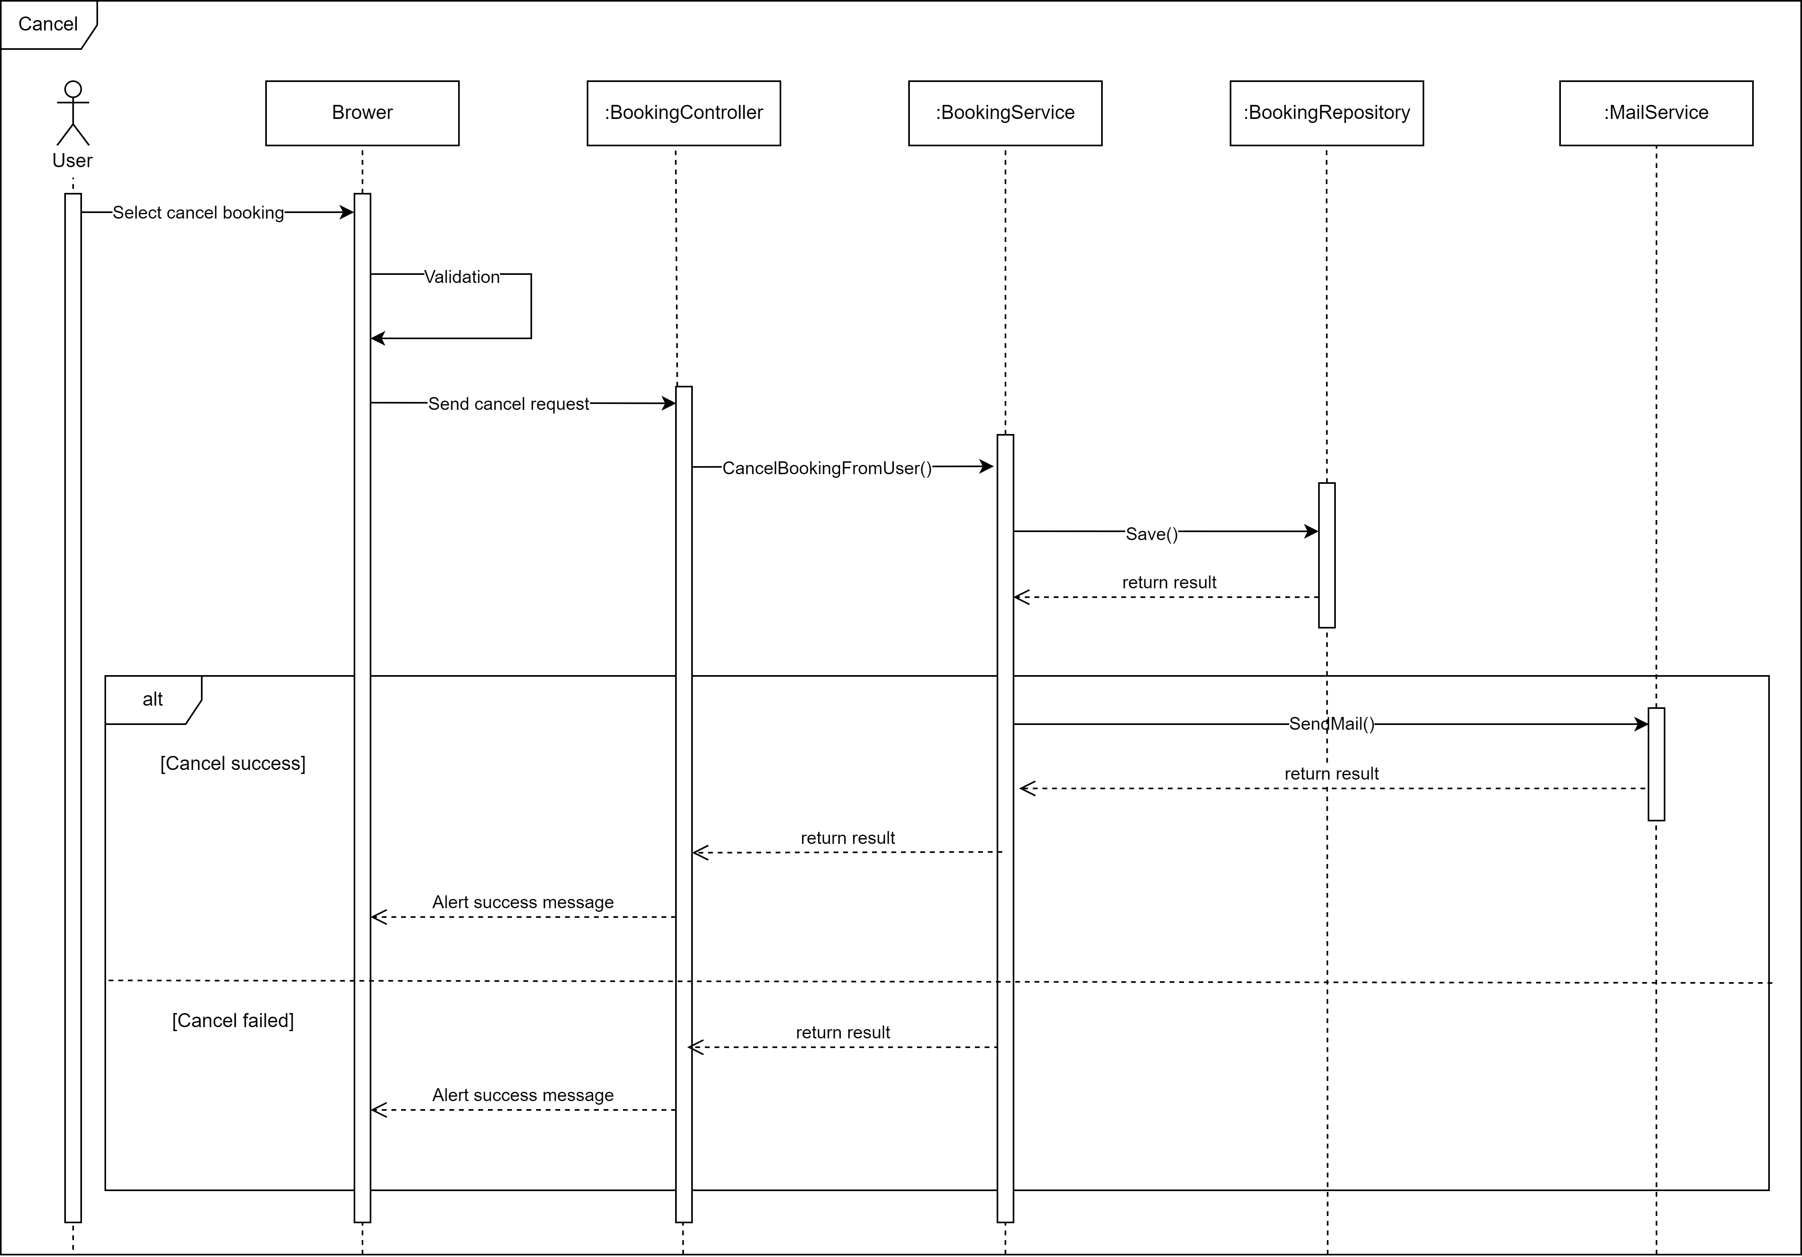

*2.4.6 User cancel booking*

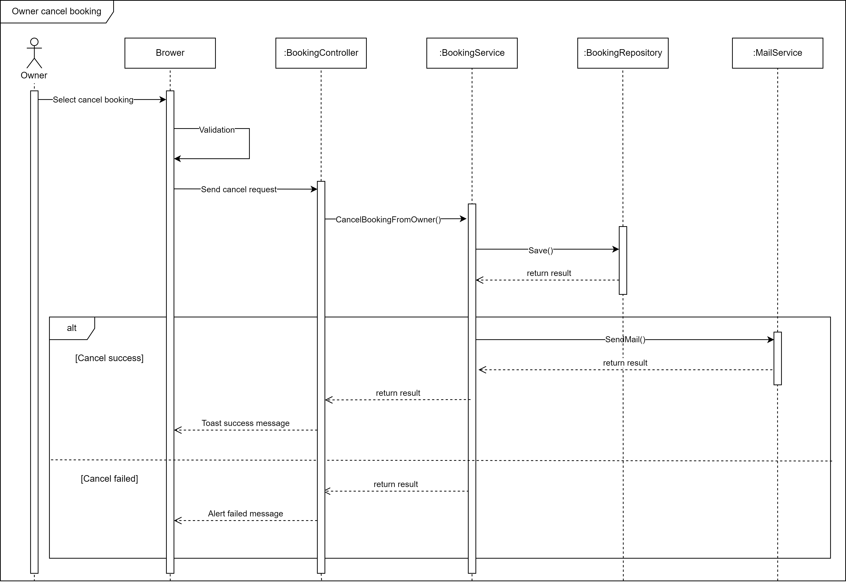

*2.4.7 Owner cancel booking*

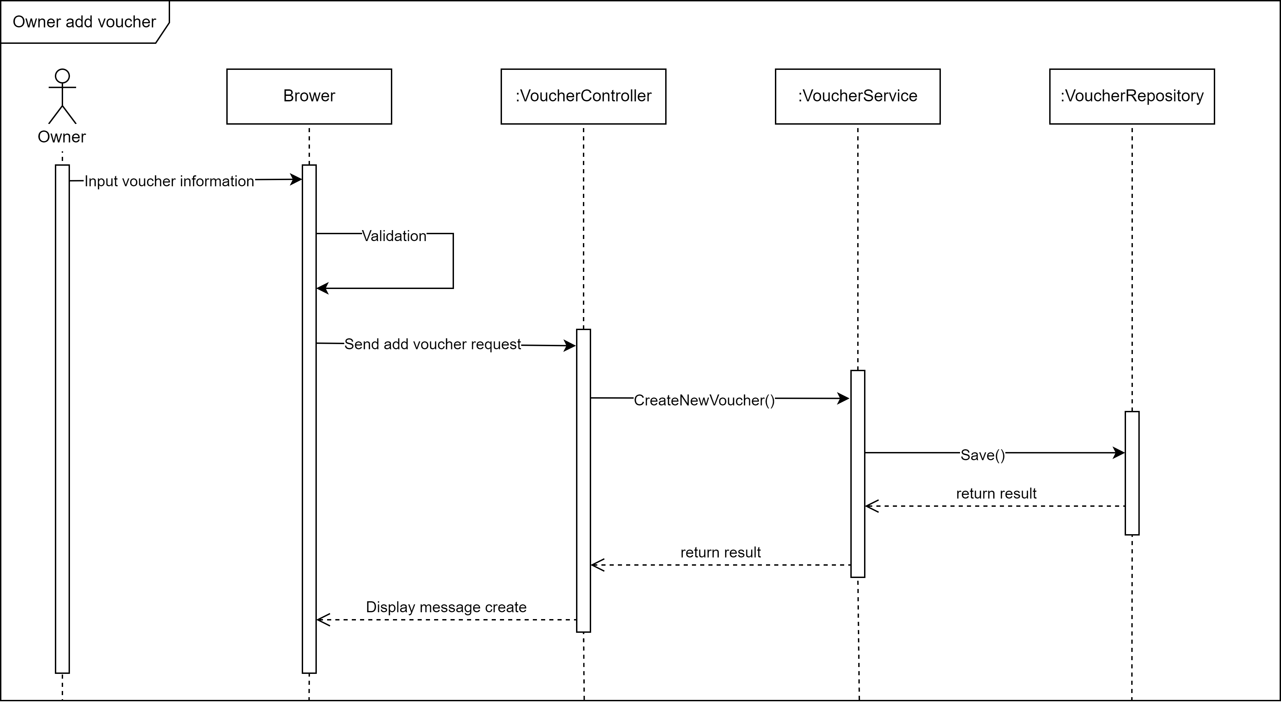

*2.4.8 Owner add voucher*

## **3. Overall Architecture**

